DAA ALL PROGRAMES

G Krishna sai
192011130

1.Identify the M-th maximum number and Nth minimum number in an array and then find the sum of it and difference of it.

Test cases: output –

{16, 16, 16 16, 16}, M = 0, N = 1 (illegal input)

{0, 0, 0, 0}, M = 1, N = 2 0

{-12, -78, -35, -42, -85}, M = 3 , N = 3 -7

{15, 19, 34, 56, 12}, M = 6 , N = -3 (illegal input)

{85, 45, 65, 75, 95}, M = 5 , N = 2 -20

Program:
#include<stdio.h>

int main(){
int size=0;
printf("Enter the total no. of elements: ");
scanf("%d",&size);

int arr[size];
printf("Enter the elements: ");
for (int i = 0; i < size; i++)
scanf("%d",&arr[i]);

int n,m;
printf("Enter the m value: ");
scanf("%d",&m);
printf("Enter the n value: ");
scanf("%d",&n);

if(m<=0 || n<=0)
printf("illegal input...!");

else if(m>size || n<0)
printf("illegal input...!");

else{
int temp=0;

for(int i=0;i<size;i++){
for(int j=0;j<size;j++){
temp=arr[i];
arr[i]=arr[j];
arr[j]=temp;
}
}

printf("Sum: %d\n",arr[size-m]+arr[n-1]);
printf("Difference: %d",arr[size-m]-arr[n-1]);
}

}

Output:
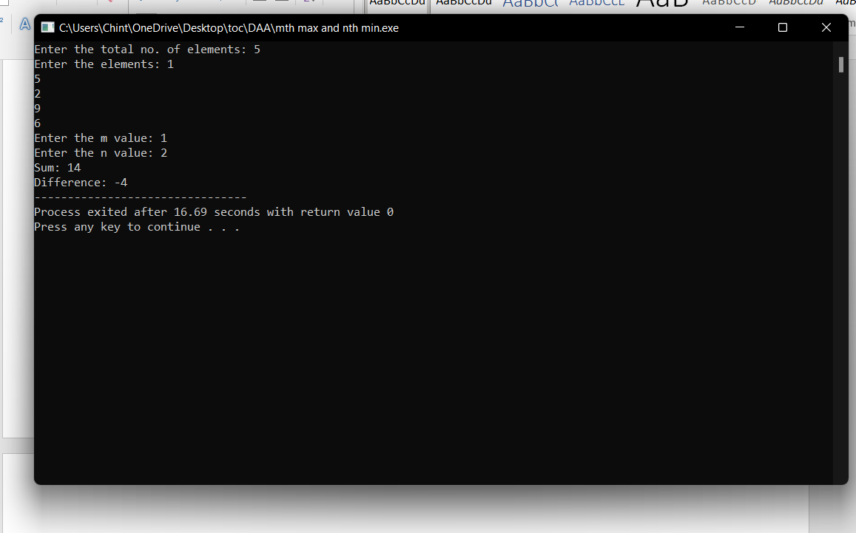

- Given an array of integers nums which is sorted in ascending order, and an integer target, write a function to search target in nums. If target exists, then return its index. Otherwise, return -1.integer target. Write a program to search a number in a list using binary search and estimate time complexity

Program:
#include<stdio.h>
int main()
{
int c=0;
int n,k,i,low,high,mid,a[50],temp;
printf("Enter number of elements:");
scanf("%d",&n);
printf("Enter elements:\n");
for(i=0;i<n;i++)
{
c++;
scanf("%d",&a[i]);
}
c++;
printf("Enter Element to search:");
scanf("%d",&k);
low=0; c++;
high=n-1; c++;
mid=low+high/2; c++;
c++;
while(low<=high)
{
c++;
c++;
if(a[mid]<k)
{
low=mid+1; c++;
}
else if(a[mid]==k)
{
printf("\nElement is found at index %d\n",mid);
break;
}
else
{
high=mid-1; c++;
}
mid=(low+high)/2; c++;
}
c++;
c++;
if(low>high)
{
printf("Element is not found\n");
}
printf("\nTime Complexity : %d\n",c);
}

Output:
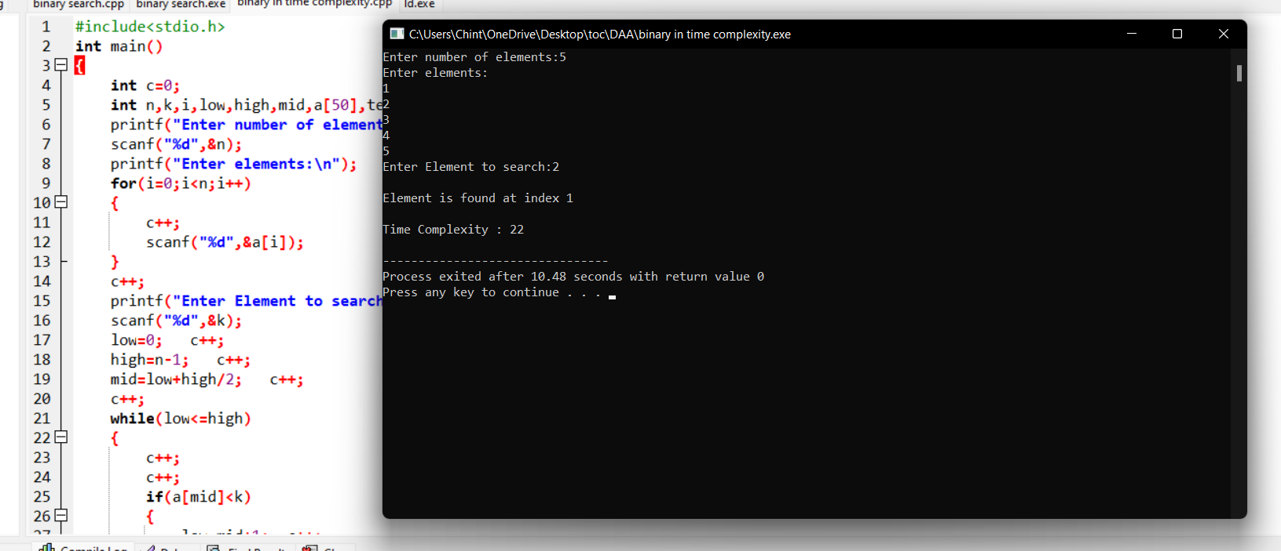

- Write a program to find the reverse of a given number. Estimate the time complexity for the following inputs

  - 1234 b. 6789456 c. 45a34 d – 5926

Program:
#include <stdio.h>

int main() {

int n, reverse = 0, remainder;

printf("Enter an integer: ");
scanf("%d", &n);

while (n != 0) {
remainder = n % 10;
reverse = reverse * 10 + remainder;
n /= 10;
}

printf("Reversed number = %d", reverse);

return 0;
}

Output:

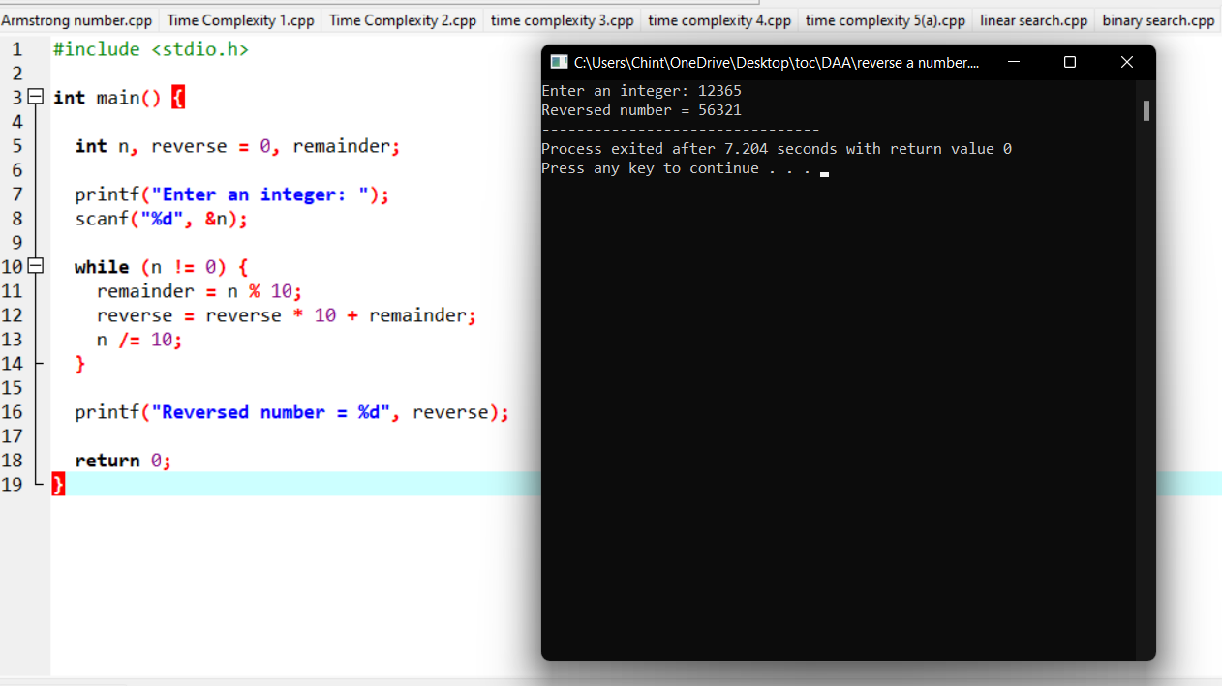

3. a program to perform sum of subsets problem using backtracking and estimate time complexity. Identify the test cases.

A. Set (s) = (6, 2,8,1,5) sum is 9 B.. Set (s) = (6, -4, 7,-1,5, 2,8,1,) sum is 10

Program:

#include <stdio.h>

char string[50], n;

void subset(int, int, int);

int main()

{

int i, len;

printf("Enter the len of main set : ");

scanf("%d", &len);

printf("Enter the elements of main set : ");

scanf("%s", string);

n = len;

printf("The subsets are :\n");

for (i = 1;i <= n;i++)

subset(0, 0, i);

}

void subset(int start, int index, int num_sub)

{

int i, j;

if (index - start + 1 == num_sub)

{

if (num_sub == 1)

{

for (i = 0;i < n;i++)

printf("%c\n", string[i]);

}

else

{

for (j = index;j < n;j++)

{

for (i = start;i < index;i++)

printf("%c", string[i]);

printf("%c\n", string[j]);

}

if (start != n - num_sub)

subset(start + 1, start + 1, num_sub);

}

}

else

{

subset(start, index + 1, num_sub);

}

}

Output: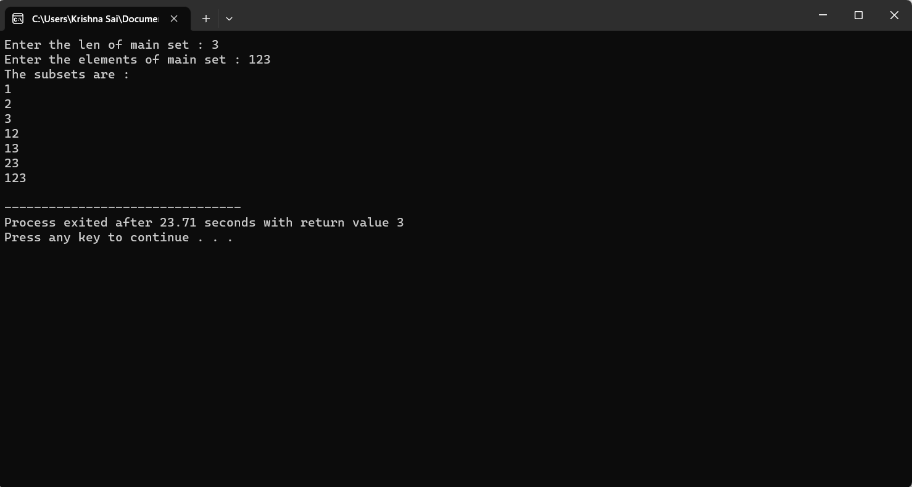

5. Write a program to check the given is Armstrong or not.
The k-digit number N is an Armstrong number if and only if the k-th power of
each digit sums to N.
Given a positive integer N, return true if and only if it is an Armstrong number.

Input : 153 Input : 419

Output : True Output : False

Program:
- #include<stdio.h>
- int main()
- {
- int n,r,sum=0,temp;
- printf("enter the number=");
- scanf("%d",&n);
- temp=n;
- while(n>0)
- {
- r=n%10;
- sum=sum+(r*r*r);
- n=n/10;
- }
- if(temp==sum)
- printf("armstrong number ");
- else
- printf("not armstrong number");
- return 0;
- }

Output:
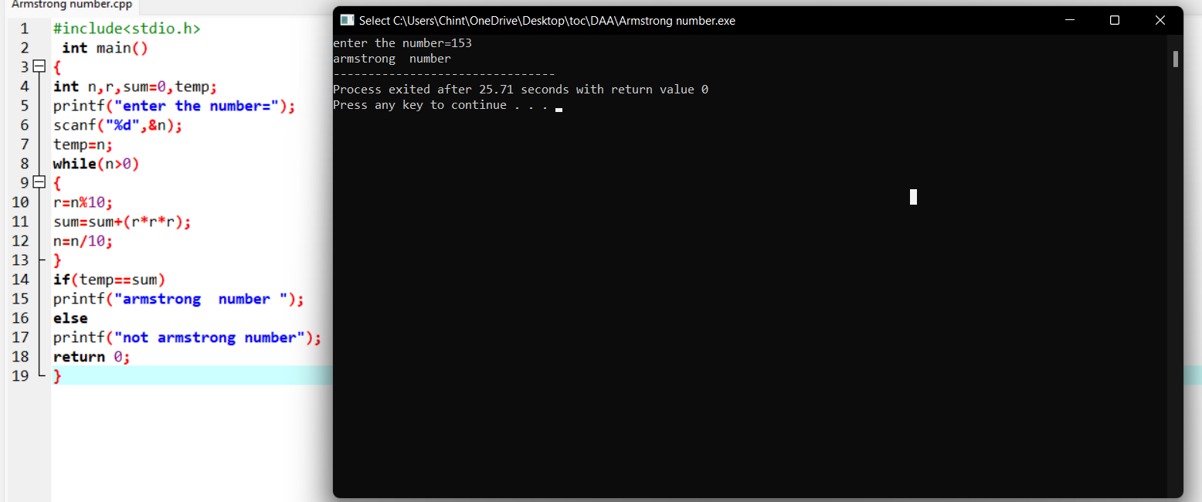

6. Write a C program to perform Strassen’s Matrix Multiplication for the 2*2 matrix elements.
And Estimate time complexity.
A Matrix= (3, 5,-4, 7) B Matrix – (9,-2, 4, 8)

Program:
#include<stdio.h>
int main(){
int a[2][2], b[2][2], c[2][2], i, j,count=0;
int m1, m2, m3, m4 , m5, m6, m7;
printf("Enter the 4 elements of first matrix:");
count++;
for(i = 0;i < 2; i++)
{
count++;
for(j = 0;j < 2; j++)
{
count++;
scanf("%d", &a[i][j]);
}
}
count++;
count++;

printf("Enter the 4 elements of second matrix: ");
for(i = 0; i < 2; i++)
{
count++;
for(j = 0;j < 2; j++)
{
count++;
scanf("%d", &b[i][j]);
}
}
count++;
count++;

printf("\nThe first matrix is\n");
for(i = 0; i < 2; i++){
count++;
printf("\n");
for(j = 0; j < 2; j++){
count++;
printf("%d\t", a[i][j]);
}
}
count++;
count++;

printf("\nThe second matrix is\n");
for(i = 0;i < 2; i++){
count++;
printf("\n");
for(j = 0;j < 2; j++){
count++;
printf("%d\t", b[i][j]);
}
}
count++;
count++;
m1= (a[0][0] + a[1][1]) * (b[0][0] + b[1][1]);
count++;
m2= (a[1][0] + a[1][1]) * b[0][0];
count++;
m3= a[0][0] * (b[0][1] - b[1][1]);
count++;
m4= a[1][1] * (b[1][0] - b[0][0]);
count++;
m5= (a[0][0] + a[0][1]) * b[1][1];
count++;
m6= (a[1][0] - a[0][0]) * (b[0][0]+b[0][1]);
count++;
m7= (a[0][1] - a[1][1]) * (b[1][0]+b[1][1]);
count++;

c[0][0] = m1 + m4- m5 + m7;
count++;
c[0][1] = m3 + m5;
count++;
c[1][0] = m2 + m4;
count++;
c[1][1] = m1 - m2 + m3 + m6;
count++;

printf("\nAfter multiplication using Strassen's algorithm \n");
for(i = 0; i < 2 ; i++){
count++;
printf("\n");
for(j = 0;j < 2; j++){
count++;
printf("%d\t", c[i][j]);
}
}
count++;
count++;

printf(" time complexity is %d",count);

return 0;
}
}

Output:
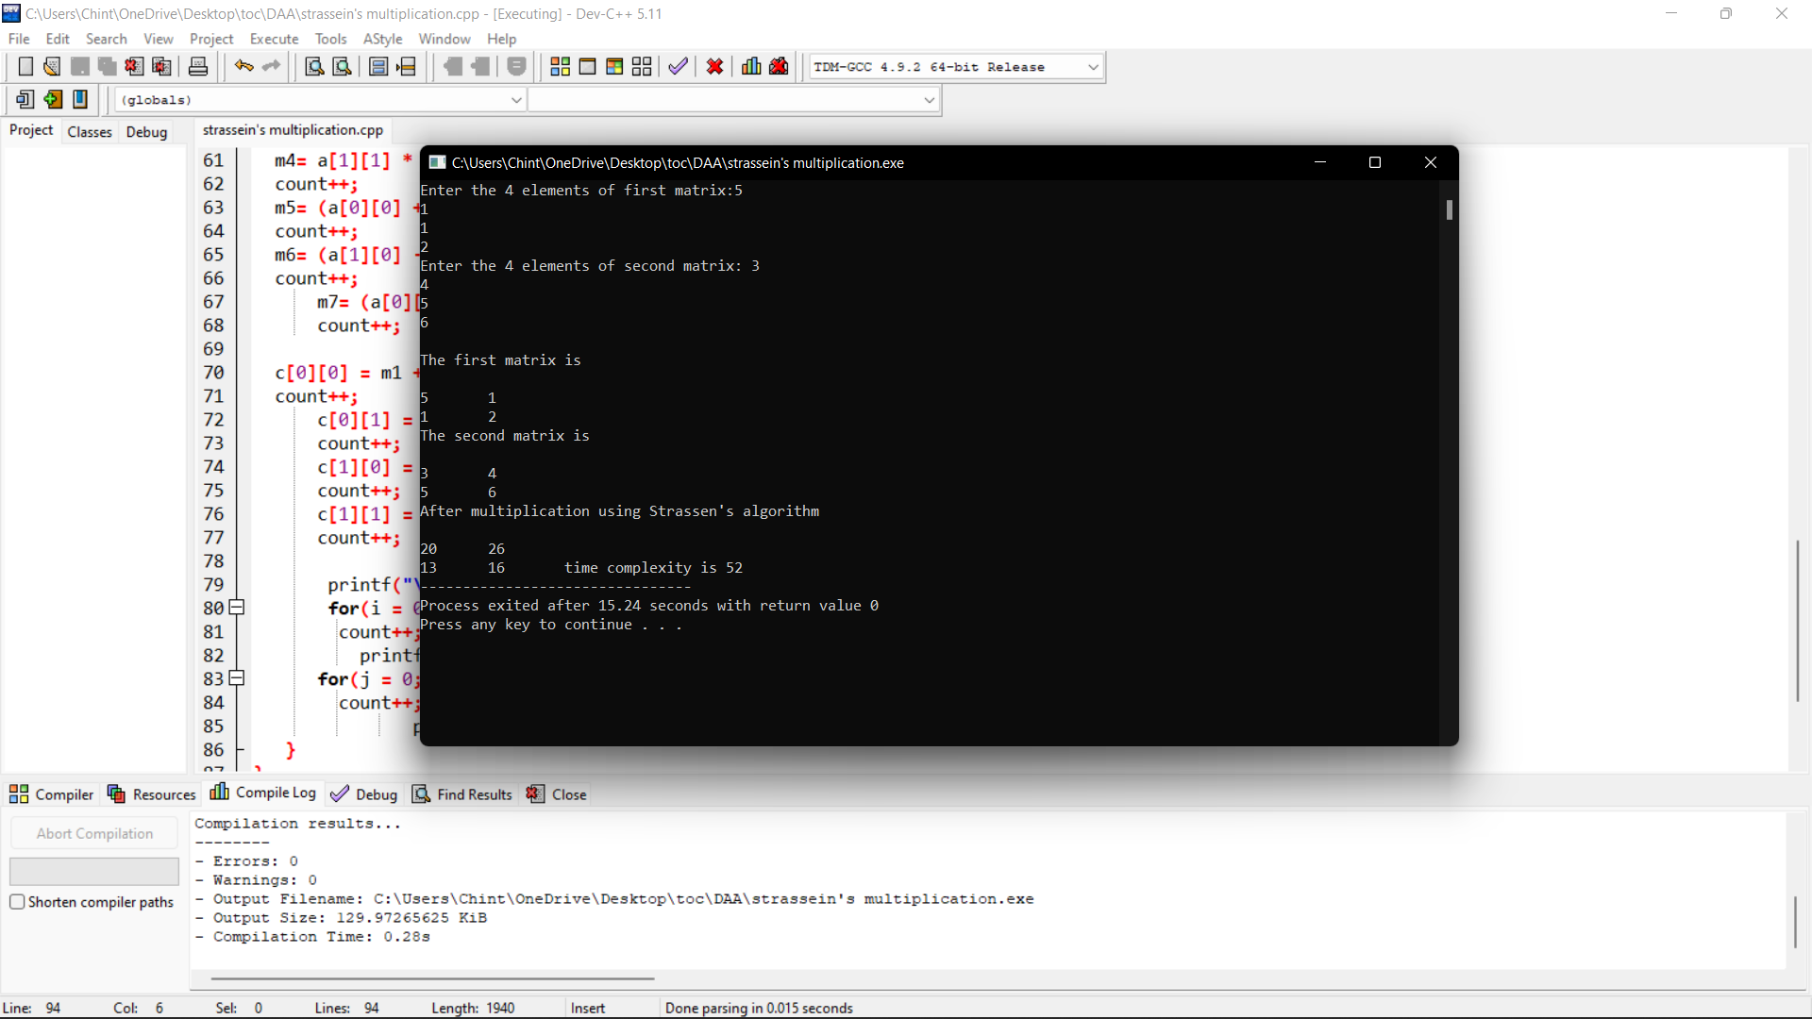

3. Write a program to generate all the reverse of a prime should be prime
( example 907 is prime and reverse 709 is also prime )
Generate all the no’s upto N and estimate time complexity.

Program:
#include <stdio.h>
int main()
{
int count=0;
int n, reverse,sum=0 , flag;
printf("Enter the prime number:");
scanf("%d",&n);
while(n!=0)
{
count++;
reverse = n%10;
count++;
sum = sum*10 + reverse;
count++;
n= n/10;
count++;
}

printf("\n");
flag = 0;
for (int j = 2; j <= sum / 2; j++)
{
count++;
if ((sum % j) == 0)
{
count++;
flag = 1;
break;
}
}
if (flag == 0)
{
count++;
printf("%d is also prinme number",sum);
}
else
{
count++;
printf("%d is Not Prime number\n",sum);
}
count++;
printf("time complexity:%d\n",count);

}

Output:
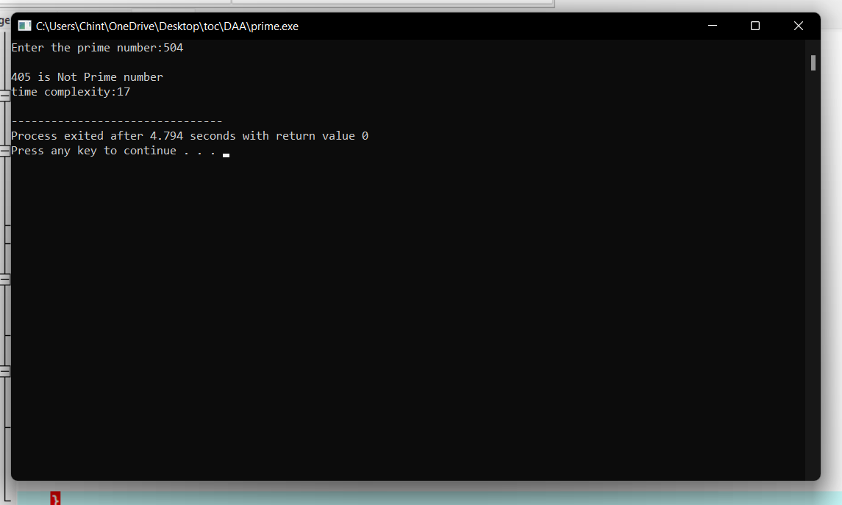

8. Let there be N workers and N jobs. Any worker can be assigned to perform any job, incurring some
cost that may vary depending on the work-job assignment. It is required to perform all jobs by
assigning exactly one worker to each job and exactly one job to each agent in such a way that the
total cost of the assignment is minimized. Write a program to solve a assignment problem for the
given data sets using branch and bound.
 | Job 1 | Job 2 | Job 3 | Job 4
Person A | 12 | 8 | 9 | 10
Person B | 11 | 10 | 10 | 9
Person C | 9 | 11 | 8 | 12
Person D | 11 | 9 | 23 | 7

#include <stdbool.h>
#include <stdio.h>
#include <stdlib.h>

typedef struct Job {

char id;
int dead;
int profit;
} Job;
int compare(const void* a, const void* b)
{
Job* temp1 = (Job*)a;
Job* temp2 = (Job*)b;
return (temp2->profit - temp1->profit);
}

int min(int num1, int num2)
{
return (num1 > num2) ? num2 : num1;
}

void printJobScheduling(Job arr[], int n)
{

qsort(arr, n, sizeof(Job), compare);

int result[n];
bool slot[n];
for (int i = 0; i < n; i++)
slot[i] = false;

for (int i = 0; i < n; i++) {

for (int j = min(n, arr[i].dead) - 1; j >= 0; j--) {

if (slot[j] == false) {
result[j] = i;
slot[j] = true;
break;
}
}
}

for (int i = 0; i < n; i++)
if (slot[i])
printf("%c ", arr[result[i]].id);
}

int main()
{
Job arr[] = { {'a', 12, 8, 9, 10 },
{ 'b', 11, 10, 10, 9 },
{ 'c', 9, 11, 8, 12 },
{ 'd', 11, 9, 23, 7 } };
int n = sizeof(arr) / sizeof(arr[0]);
printf(
"Following is maximum profit sequence of jobs \n");

printJobScheduling(arr, n);
return 0;
}
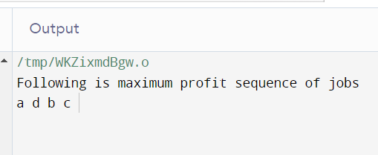

9. Compute the program to find the GCD of two numbers. And also find the finf of time Recursion
used to estimate time complexity.
Perform the test cases for the given set of no’s
- (36,48) B. (144, 90) C. (-56,88) D. (84,84)

Program:
#include <stdio.h>
int main()
{
int n1, n2, i, GCD_Num;
int count=0;
printf ( " Enter any two numbers: \n ");
scanf ( "%d %d", &n1, &n2);

for( i = 1; i <= n1 && i <= n2; ++i)
{
count++;
if (n1 % i ==0 && n2 % i == 0)
GCD_Num = i;
count++;
}
count++;

printf ("gcd of two numbers %d and %d is %d \n ", n1, n2, GCD_Num);
printf("time complexity :%d ",count);
return 0;
}

Output:
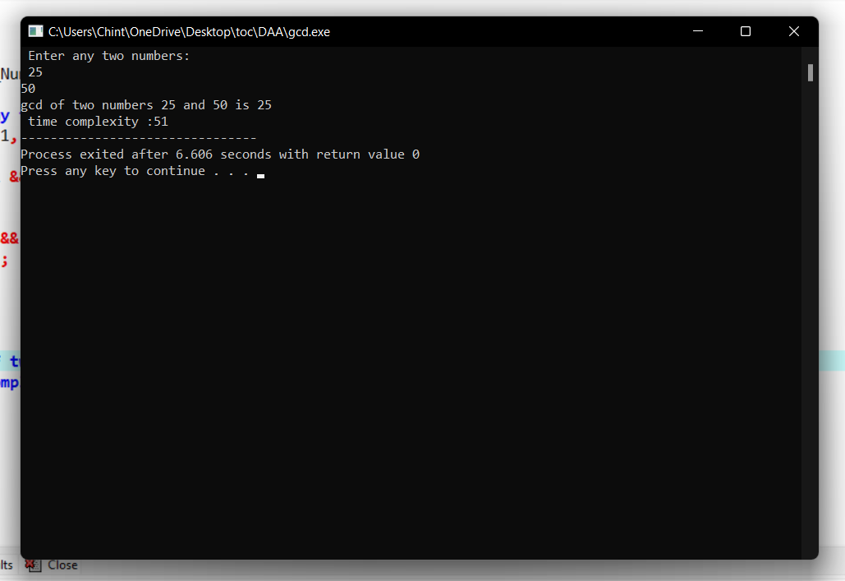

10. Using Divide and Conquer strategy to find Max and Min value in the list and estimate time
complexity.
Testing Condition – Count the number of times in Comparion to find Min_Max value
in a list n for the given set of elements.
- (23,45,6,8,-9,44,7,8)
- (8,-5,7,2,6,0,1,9)
- (45, y, 9, 8,4, 7,11, 22,16)

Program:
#include<stdio.h>
#include<stdio.h>
int max, min;
int a[100];
void maxmin(int i, int j)
{
int max1, min1, mid;
if(i==j)
{
max = min = a[i];
}
else
{
if(i == j-1)
{
if(a[i] <a[j])
{
max = a[j];
min = a[i];
}
else
{
max = a[i];
min = a[j];
}
}
else
{
mid = (i+j)/2;
maxmin(i, mid);
max1 = max; min1 = min;
maxmin(mid+1, j);
if(max <max1)
max = max1;
if(min > min1)
min = min1;
}
}
}
int main ()
{
int i, num;
printf ("\nEnter the total number of numbers : ");
scanf ("%d",&num);
printf ("Enter the numbers : \n");
for (i=1;i<=num;i++)
scanf ("%d",&a[i]);

max = a[0];
min = a[0];
maxmin(1, num);
printf ("Minimum element in an array : %d\n", min);
printf ("Maximum element in an array : %d\n", max);
return 0;
}

Output:
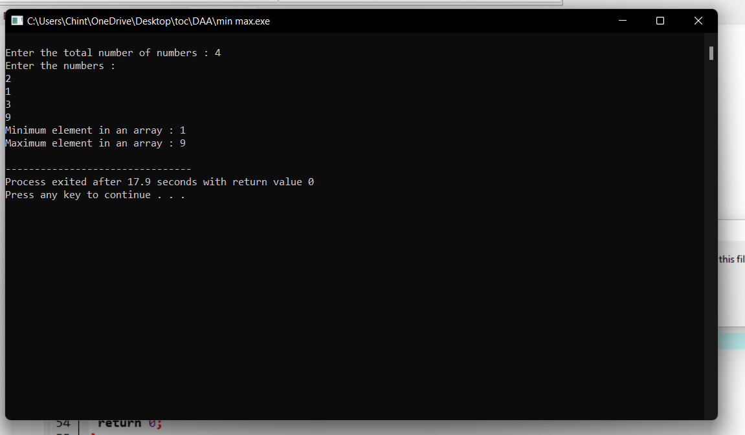
11. Generate a program for Pascal triangle.
Estimate the time complexity for the row=5
 |  |  |  | 1
 |  |  | 1 |  | 1
 |  | 1 |  | 2 |  | 1
 | 1 |  | 3 |  | 3 |  | 1
1 |  | 4 |  | 6 |  | 4 |  | 1

Program:
#include<stdio.h>
int main()
{
int rows, coef = 1, space, i, j;
int count=0;
printf("Enter the number of rows: ");
scanf("%d", &rows);
for (i = 0; i<rows; i++)
{
count++;
for (space = 1; space <= rows - i; space++)
printf(" ");
count++;
for (j = 0; j <= i; j++)
{
count++;
if(j == 0 || i == 0){
coef = 1;
count++;
}

else
{
coef = coef * (i - j + 1) / j;
}
count++;
printf("%4d", coef);
}
printf("\n");
count++;
}
printf("time complexity:%d",count);
return 0;
}

Output:
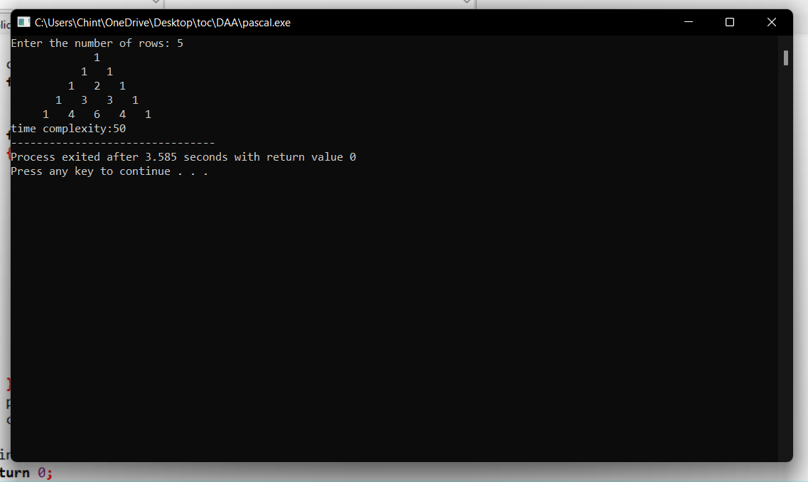

12. Compute Binomial coefficient for n=8, k=8 using dynamic programming
Using condition such as
I nCk =1 if k=0 or n=k
II nCk – (n-1)Ck-1 + (n-1)Ck for n>k>0

Program:
#include <stdio.h>
int count=0;
int bin_table(int val) {
for (int i = 0; i <= val; i++) {
count++;
printf("%2d", i);
int num = 1;
for (int j = 0; j <= i; j++) {
count++;
if (i != 0 && j != 0)
num = num * (i - j + 1) / j;
count++;
printf("%4d", num);
}
printf("\n");
count++;
}
}
int main() {
int value = 5;
bin_table(value);
printf("Time complexity:%d",count);
return 0;
}

Output:
0 1
1 1 1
2 1 2 1
3 1 3 3 1
4 1 4 6 4 1
5 1 5 10 10 5 1
Time complexity:54
--------------------------------

13. Write a program to find the largest element value in an array. Estimate the time complexity and no of
comparison for the given set of values.
Program:
#include <stdio.h>
int main() {
int n;
int count=0;
double arr[100];
printf("Enter the number of elements (1 to 100): ");
scanf("%d", &n);
count++;
for (int i = 0; i < n; ++i) {
count++;
printf("Enter number%d: ", i + 1);
scanf("%lf", &arr[i]);
}
for (int i = 1; i < n; ++i) {
count++;
if (arr[0] < arr[i]) {
arr[0] = arr[i];
}
count++;
}

printf("Largest element = %.2lf \n ", arr[0]);
printf("time complexity:%d\n",count);
return 0;
}

Output:
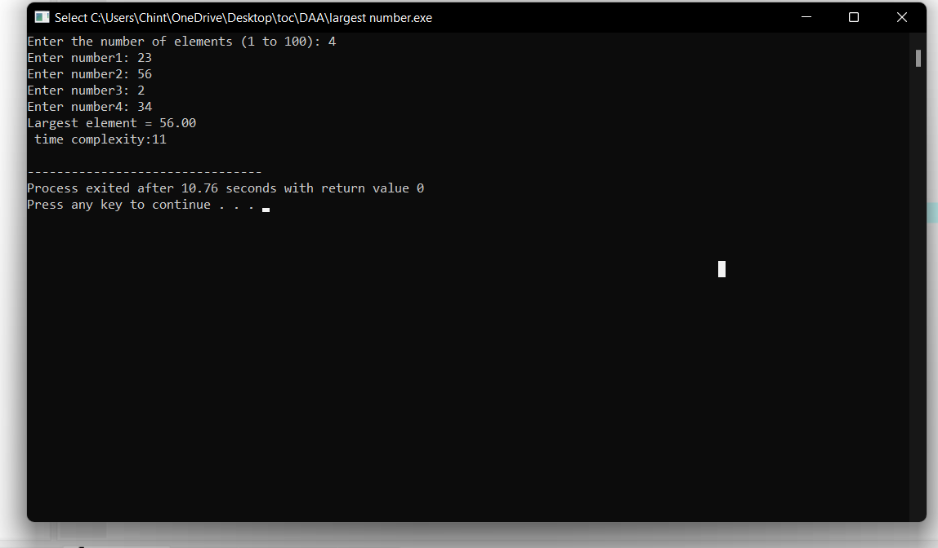
14. Consider a two integer arrays nums1 and nums2, sorted in non-increasing order and two integers m
and n, representing the number of elements in nums1 and nums2 respectively. Write a program to
Merge them into a single array using Merge Sort. Derive time complexity of merge sort.
Program:
#include <stdio.h>
#include <stdlib.h>

// Merges two subarrays of arr[].
// First subarray is arr[l..m]
// Second subarray is arr[m+1..r]
void merge(int arr[], int l,
int m, int r)
{
int i, j, k;
int n1 = m - l + 1;
int n2 = r - m;

// Create temp arrays
int L[n1], R[n2];

// Copy data to temp arrays
// L[] and R[]
for (i = 0; i < n1; i++)
L[i] = arr[l + i];
for (j = 0; j < n2; j++)
R[j] = arr[m + 1 + j];

// Merge the temp arrays back
// into arr[l..r]
// Initial index of first subarray
i = 0;

// Initial index of second subarray
j = 0;

// Initial index of merged subarray
k = l;
while (i < n1 && j < n2)
{
if (L[i] <= R[j])
{
arr[k] = L[i];
i++;
}
else
{
arr[k] = R[j];
j++;
}
k++;
}

// Copy the remaining elements
// of L[], if there are any
while (i < n1) {
arr[k] = L[i];
i++;
k++;
}

// Copy the remaining elements of
// R[], if there are any
while (j < n2)
{
arr[k] = R[j];
j++;
k++;
}
}

// l is for left index and r is
// right index of the sub-array
// of arr to be sorted
void mergeSort(int arr[],
int l, int r)
{
if (l < r)
{
// Same as (l+r)/2, but avoids
// overflow for large l and h
int m = l + (r - l) / 2;

// Sort first and second halves
mergeSort(arr, l, m);
mergeSort(arr, m + 1, r);

merge(arr, l, m, r);
}
}

// UTILITY FUNCTIONS
// Function to print an array
void printArray(int A[], int size)
{
int i;
for (i = 0; i < size; i++)
printf("%d ", A[i]);
printf("\n");
}

// Driver code
int main()
{
int arr[] = {12, 11, 13, 5, 6, 7};
int arr_size = sizeof(arr) / sizeof(arr[0]);

printf("Given array is \n");
printArray(arr, arr_size);

mergeSort(arr, 0, arr_size - 1);

printf("\nSorted array is \n");
printArray(arr, arr_size);
return 0;
}

Output:
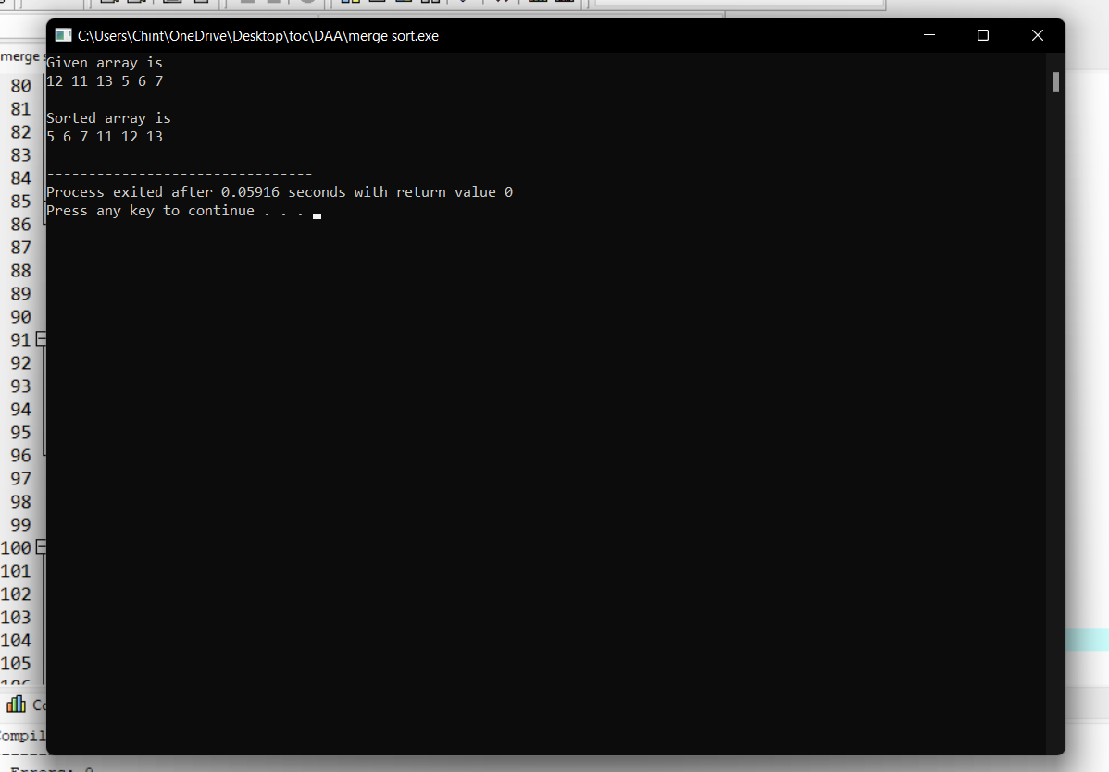
15.Write a program to find all pair shortest path using Floyds technique and to estimate time complexity.

 | A | B | C | D
A | 0 | 8 | 7 | 8
B | 9 | 0 | 11 | 12
C | 10 | 9 | 0 | 11
D | 8 | 10 | 11 | 0

Program:
#include <stdio.h>

// defining the number of vertices
#define nV 4

#define INF 999

void printMatrix(int matrix[][nV]);

// Implementing floyd warshall algorithm
void floydWarshall(int graph[][nV]) {
int matrix[nV][nV], i, j, k;

for (i = 0; i < nV; i++)
for (j = 0; j < nV; j++)
matrix[i][j] = graph[i][j];

// Adding vertices individually
for (k = 0; k < nV; k++) {
for (i = 0; i < nV; i++) {
for (j = 0; j < nV; j++) {
if (matrix[i][k] + matrix[k][j] < matrix[i][j])
matrix[i][j] = matrix[i][k] + matrix[k][j];
}
}
}
printMatrix(matrix);
}

void printMatrix(int matrix[][nV]) {
for (int i = 0; i < nV; i++) {
for (int j = 0; j < nV; j++) {
if (matrix[i][j] == INF)
printf("%4s", "INF");
else
printf("%4d", matrix[i][j]);
}
printf("\n");
}
}

int main() {
int graph[nV][nV] = {{0, 8, INF, 8},
{9, 0, INF, 12},
{INF, 9, 0, INF},
{INF, INF, 11, 0}};
floydWarshall(graph);
}

Output:
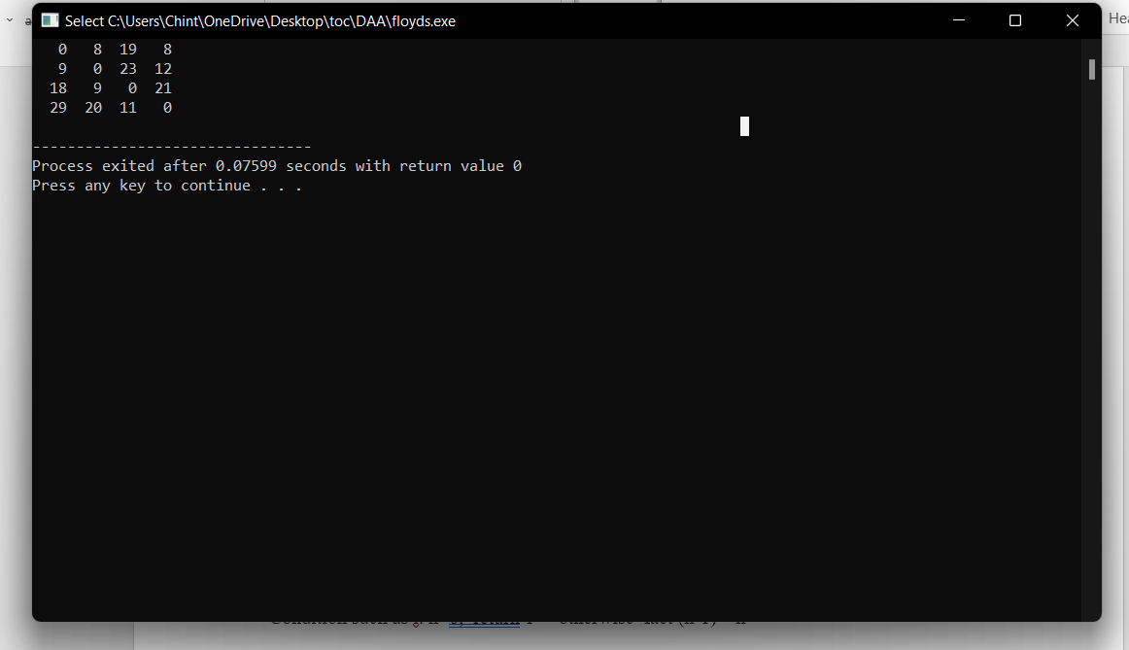
- N = 0.2

.16.Write a program for to perform liner search and estimate time complexity. Compute the
amount of time for completion.
Input series
A = (56,89,7,13,75, 23, 8, 12) Key element 75
B= (89,45 -23,45,0, 44, 2) Key element 0
C= (45,67,56,A,34,-2,100) Key element 90

Program:
#include<stdio.h>
int main()
{
int c=0;
int n,k,i,j,f=0,a[50];
c++;
printf("Enter number of elements:");
scanf("%d",&n);
printf("Enter elements:\n");
for(i=0;i<n;i++)
{
c++;
scanf("%d",&a[i]);
}
c++;
printf("Enter Element to search:");
scanf("%d",&k);
for(i=0;i<n;i++)
{
c++;
c++;
if(k==a[i])
{
printf("Element is found at index %d\n",i);
f=1;
c++;
}
}
c++;
c++;
if(f==0)
{
printf("Element is not found");
}
printf("\nTime Complexity : %d",c);
}

Output:
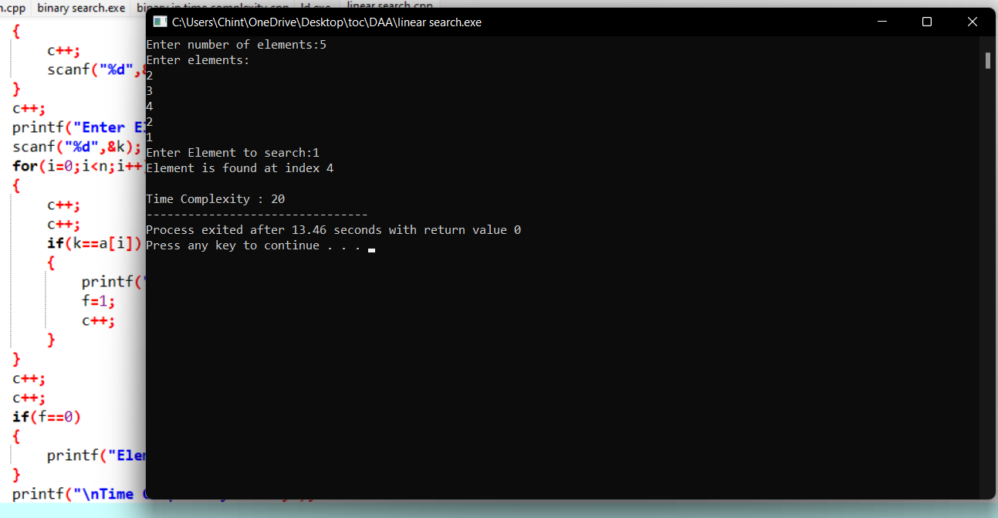
17. Write a program to find the factorial (fact)of a number and to estimate time complexity.
Condition such as i. n=0, return 1 otherwise fact (n-1) * n
Program:

#include <stdio.h>
int main() {
int n, i;
int count=0;
unsigned long long fact = 1;
printf("Enter an integer: ");
scanf("%d", &n);
count++;
if (n < 0)
printf("Error! Factorial of a negative number doesn't exist.");
else {
for (i = 1; i <= n; ++i) {
fact *= i;
count++;
}
printf("Factorial of %d = %llu \n ", n, fact);
printf(" time compexity : %d ",count);
}

return 0;
}
Output:
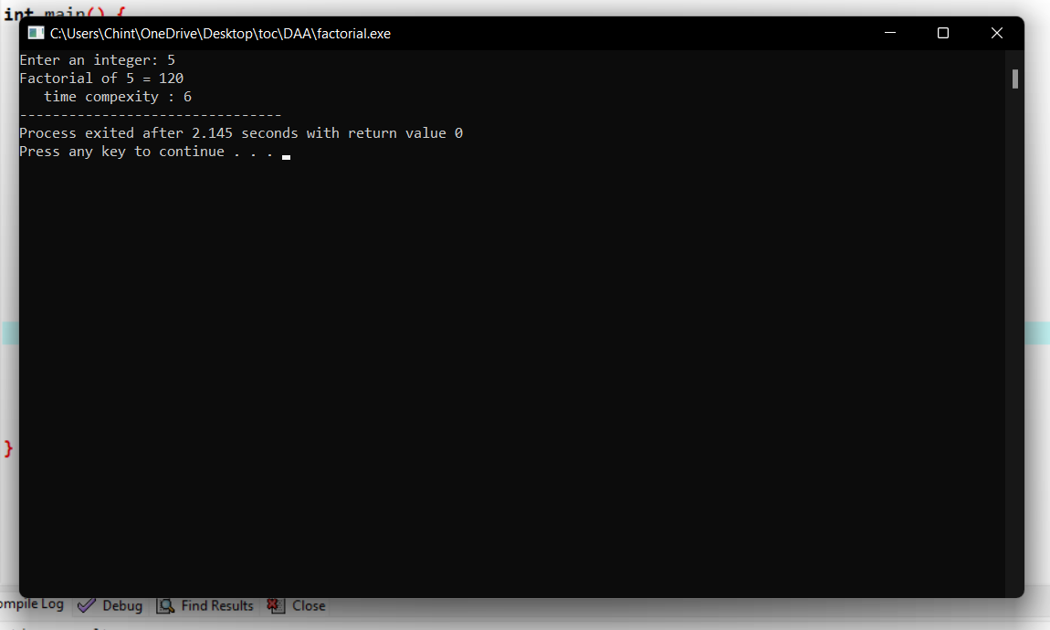
18.Write a program to perform Knapsack problem for the following set of object values.,
Knapsack weight 100

item | Weight | Profit
1 | 40 | 80
2 | 30 | 70
3 | 20 | 50
4 | 30 | 80
Program:
# include<stdio.h>

void knapsack(int n, float weight[], float profit[], float capacity) {
float x[20], tp = 0;
int i, j, u;
u = capacity;

for (i = 0; i < n; i++)
x[i] = 0.0;

for (i = 0; i < n; i++) {
if (weight[i] > u)
break;
else {
x[i] = 1.0;
tp = tp + profit[i];
u = u - weight[i];
}
}

if (i < n)
x[i] = u / weight[i];

tp = tp + (x[i] * profit[i]);

printf("\nThe result vector is:- ");
for (i = 0; i < n; i++)
printf("%f\t", x[i]);

printf("\nMaximum profit is:- %f", tp);

}

int main() {
float weight[20], profit[20], capacity;
int num, i, j;
float ratio[20], temp;

printf("\nEnter the no. of objects:- ");
scanf("%d", &num);

printf("\nEnter the wts and profits of each object:- ");
for (i = 0; i < num; i++) {
scanf("%f %f", &weight[i], &profit[i]);
}

printf("\nEnter the capacityacity of knapsack:- ");
scanf("%f", &capacity);

for (i = 0; i < num; i++) {
ratio[i] = profit[i] / weight[i];
}

for (i = 0; i < num; i++) {
for (j = i + 1; j < num; j++) {
if (ratio[i] < ratio[j]) {
temp = ratio[j];
ratio[j] = ratio[i];
ratio[i] = temp;

temp = weight[j];
weight[j] = weight[i];
weight[i] = temp;

temp = profit[j];
profit[j] = profit[i];
profit[i] = temp;
}
}
}

knapsack(num, weight, profit, capacity);
return(0);
}

Output:
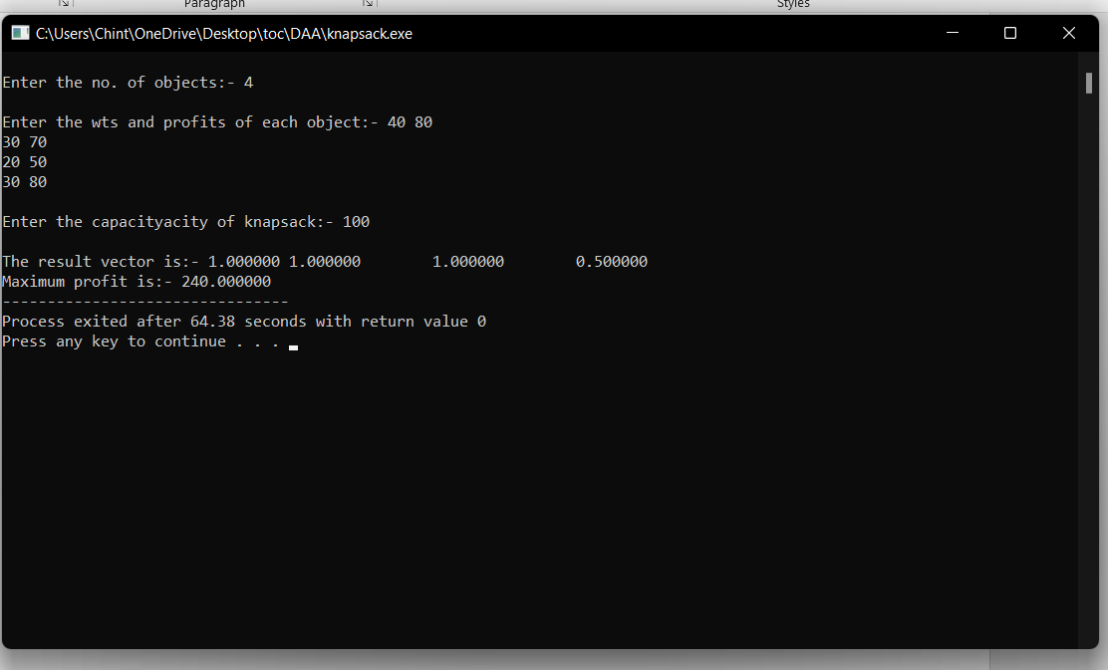
19.Write a program to print the first n perfect numbers. (Hint Perfect number means a positive integer that is equal to the sum of its proper divisors)
Sample Input:
N = 3
Sample Output:
First 3 perfect numbers are: 6 , 28 , 496
Test Cases:
- N = 0
- N = 5
- N = -2
- N = -5
Program:
#include <stdio.h>

int main()
{
int i, j, end, sum;

/* Input upper limit to print perfect number */
printf("Enter upper limit: ");
scanf("%d", &end);

printf("All Perfect numbers between 1 to %d:\n", end);

/* Iterate from 1 to end */
for(i=1; i<=end; i++)
{
sum = 0;

/* Check whether the current number i is Perfect number or not */
for(j=1; j<i; j++)
{
if(i % j == 0)
{
sum += j;
}
}

/* If the current number i is Perfect number */
if(sum == i)
{
printf("%d, ", i);
}
}

return 0;
}

Output:
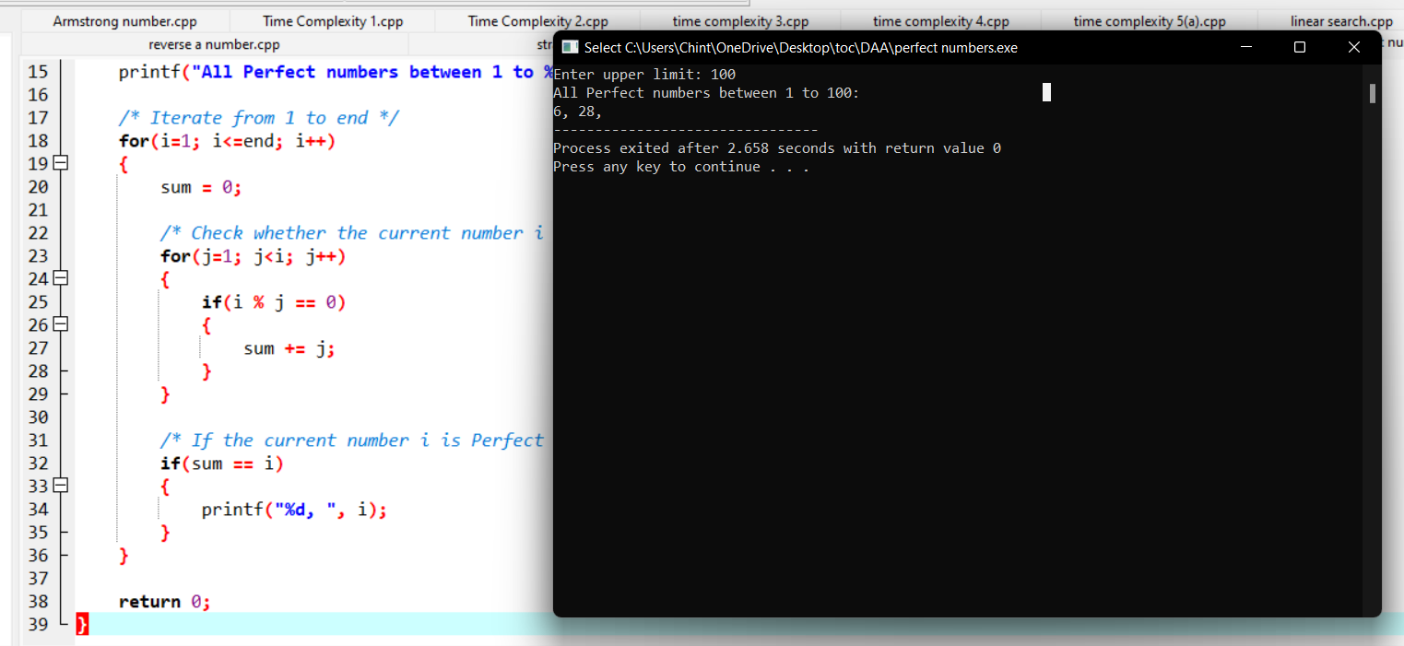
20.Program to Find Even Sum of Fibonacci Series Till number N?(day 2)
Sample Input: n = 4
Sample Output: 33
(N = 4, So here the Fibonacci series will be produced from 0th term till 8th term: 0, 1, 1, 2, 3, 5, 8, 13, 21
Sum of numbers at even indexes = 0 + 1 + 3 + 8 + 21 = 33)

Program:
#include<stdio.h>
int fab(int n){
int n1=0,n2=1,n3,c=0,sum=0,ini=0;
int count=0;
printf("%d %d ",n1,n2);
while(c<n){
count++;
n3=n1+n2;
count++;
printf("%d ",n3);
if(ini%2==0){
count++;
sum+=n3;
count++;
c++;
count++;
}
ini++;
count++;
n1=n2;
count++;
n2=n3;
count++;
}count++;
printf("\nsum: %d\n",sum);
printf("Time complexity: %d",count);
return 0;
}

int main(){
int n;
printf("Enter the n value: ");
scanf("%d",&n);
fab(n);
}

Output:
Enter the n value: 4
0 1 1 2 3 5 8 13 21
sum: 33
Time complexity: 48
--------------------------------

21.Write a program to perform Selection sort and estimate time Complexity
Estimate the time iteration for the following set of numbers.
- (10,5, 80,-2,5,23, 45) B. (12, 3, 0, 34, -11, 34, 22, 8) C.( 3, 35, -56, 66, 77, ,-78, 82)

Program:
#include <stdio.h>
void selectionSort(int arr[], int size);
void swap(int *a, int *b);
void selectionSort(int arr[], int size)
{
int i, j;
for (i = 0 ; i < size;i++)
{
for (j = i ; j < size; j++)
{
if (arr[i] > arr[j])
swap(&arr[i], &arr[j]);
}
}
}
void swap(int *a, int *b)
{
int temp;
temp = *a;
*a = *b;
*b = temp;
}
int main()
{
int array[10], i, size;
printf("How many numbers you want to sort: ");
scanf("%d", &size);
printf("\nEnter %d numbers\t", size);
printf("\n");
for (i = 0; i < size; i++)
scanf("%d", &array[i]);
selectionSort(array, size);
printf("\nSorted array is ");
for (i = 0; i < size;i++)
printf(" %d ", array[i]);
return 0;
}

Output:
How many numbers you want to sort: 5

Enter 5 numbers
5
6
1
4
2

Sorted array is 1 2 4 5 6
--------------------------------

22. Determine an optimal tour in a weighted, directed graph. The weights are nonnegative numbers. The
inputs are weighted, directed graph, and n, the number of vertices in the graph. The graph is
represented by a two-dimensional array W, which has both its rows and columns indexed from 1 to n,
where W [i] [j] is the weight on the edge from the ith vertex to the jth vertex. Write a program for
travelling salesman problem using dynamic programming for the below given graph.

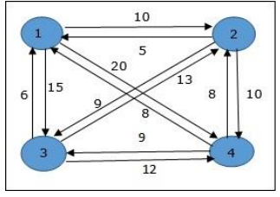
Program:
#include <iostream>

using namespace std;
const int n = 4;
const int MAX = 1000000;
int dist[n + 1][n + 1] = {
{ 0, 0, 0, 0, 0 }, { 0, 0, 10, 15, 20 },
{ 0, 10, 0, 25, 25 }, { 0, 15, 25, 0, 30 },
{ 0, 20, 25, 30, 0 },
};

int memo[n + 1][1 << (n + 1)];

int fun(int i, int mask)
{

if (mask == ((1 << i) | 3))
return dist[1][i];

if (memo[i][mask] != 0)
return memo[i][mask];

int res = MAX;

for (int j = 1; j <= n; j++)
if ((mask & (1 << j)) && j != i && j != 1)
res = std::min(res, fun(j, mask & (~(1 << i)))
+ dist[j][i]);
return memo[i][mask] = res;
}

int main()
{
int ans = MAX;
for (int i = 1; i <= n; i++)
ans = std::min(ans, fun(i, (1 << (n + 1)) - 1)
+ dist[i][1]);

printf("The cost of most efficient tour = %d", ans);

return 0;
}
Output:
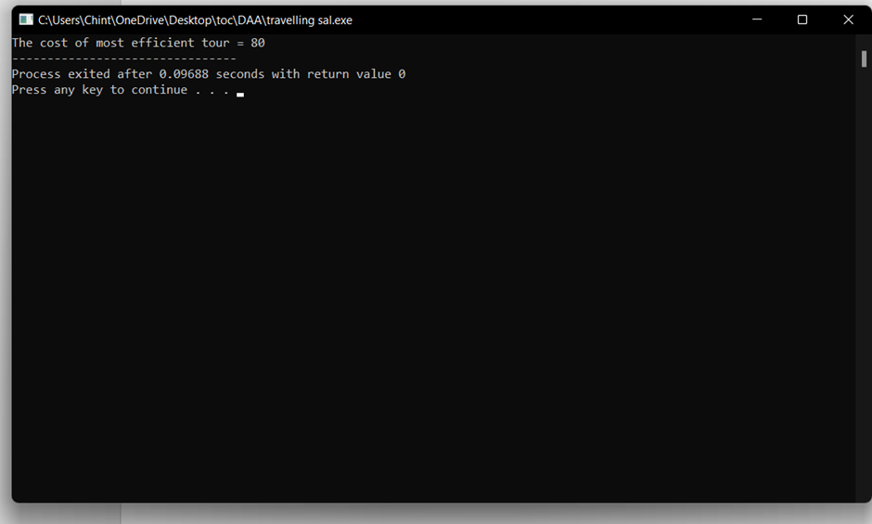

23. Write a program using choice to check
Case 1: Given string is palindrome or not
Case 2: Given number is palindrome or not
Sample Input:
Case = 1
String = MADAM
Sample Output:
Palindrome
Test cases:
- MONEY
- 5678765
- MALAY12321ALAM
- MALAYALAM
- 1234.4321

#include <stdio.h>
#include <string.h>
int main(){
char string1[20];
int i, length;
int flag = 0;

printf("Enter a string:");
scanf("%s", string1);

length = strlen(string1);

for(i=0;i < length ;i++){
if(string1[i] != string1[length-i-1]){
flag = 1;
break;
}
}

if (flag) {
printf("%s is not a palindrome", string1);
}
else {
printf("%s is a palindrome", string1);
}
return 0;
}

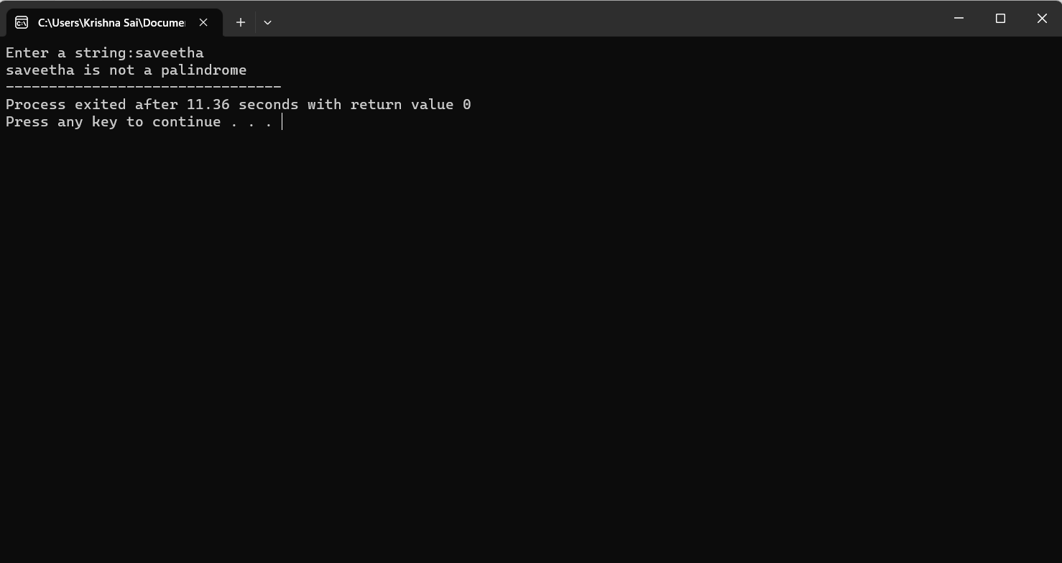

24.Write a program to inset a number in a list
Testing Condition
    - Insert at the beginning
    - Insert in the middle
    - Insert at the last
    - Not Available position in a list

Program:
#include<stdio.h>
#include<stdlib.h>

#define MAX 100

int list[MAX];
int position, num, size = 0;

void insertAtBeginning() {
int i;
if (size == MAX) {
printf("List is full. Cannot insert at the beginning\n");
return;
}

for (i = size; i > 0; i--) {
list[i] = list[i - 1];
}

list[0] = num;
size++;
printf("Number %d inserted at position %d\n", num, position);
}

void insertInMiddle() {
int i;
if (size == MAX) {
printf("List is full. Cannot insert in the middle\n");
return;
}

for (i = size; i > position - 1; i--) {
list[i] = list[i - 1];
}

list[position - 1] = num;
size++;
printf("Number %d inserted at position %d\n", num, position);
}

void insertAtLast() {
if (size == MAX) {
printf("List is full. Cannot insert at the end\n");
return;
}

list[size] = num;
size++;
printf("Number %d inserted at position %d\n", num, size);
}

int main() {
int choice;
while (1) {
printf("1. Insert at the beginning\n");
printf("2. Insert in the middle\n");
printf("3. Insert at the last\n");
printf("4. Exit\n");
printf("Enter your choice: ");
scanf("%d", &choice);

switch (choice) {
case 1:
printf("Enter the number to insert: ");
scanf("%d", &num);
position = 1;
insertAtBeginning();
break;

case 2:
printf("Enter the number to insert: ");
scanf("%d", &num);
printf("Enter the position to insert the number: ");
scanf("%d", &position);
if (position < 1 || position > size + 1) {
printf("Invalid position\n");
} else {
insertInMiddle();
}
break;

case 3:
printf("Enter the number to insert: ");
scanf("%d", &num);
position = size + 1;
insertAtLast();
break;

case 4:
exit(0);

default:
printf("Invalid choice\n");
break;
}
}

return 0;
}

Output:
Insert at the beginning
2. Insert in the middle
3. Insert at the last
4. Exit
Enter your choice: 1
Enter the number to insert: 5
Number 5 inserted at position 1
1. Insert at the beginning
2. Insert in the middle
3. Insert at the last
4. Exit
Enter your choice: 2
Enter the number to insert: 6
Enter the position to insert the number: 2
Number 6 inserted at position 2
1. Insert at the beginning
2. Insert in the middle
3. Insert at the last
4. Exit
Enter your choice: 3
Enter the number to insert: 4
Number 4 inserted at position 3
1. Insert at the beginning
2. Insert in the middle
3. Insert at the last
4. Exit
Enter your choice: 4

------------------------

25.The n-queens puzzle is the problem of placing n queens on an n x n chessboard such that no two queens attack each other. Given an integer n, return all distinct solutions to the n-queens puzzle. You may return the answer in any order. Write a program for the same.
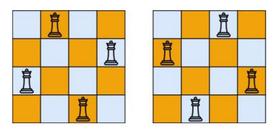
Program:
#include<stdio.h>
#include<conio.h>
#include<math.h>
int a[30],count=0;
int place(int pos) {
int i;
for (i=1;i<pos;i++) {
if((a[i]==a[pos])||((abs(a[i]-a[pos])==abs(i-pos))))
return 0;
}
return 1;
}
void print_sol(int n) {
int i,j;
count++;
printf("\n\ntime comolexity #%d:\n",count);
for (i=1;i<=n;i++) {
for (j=1;j<=n;j++) {
if(a[i]==j)
printf("Q\t"); else
printf("*\t");

}
printf("\n");
}
}
void queen(int n) {
int k=1;
a[k]=0;
while(k!=0) {
a[k]=a[k]+1;
while((a[k]<=n)&&!place(k))
a[k]++;
if(a[k]<=n) {
if(k==n)
print_sol(n); else {
k++;
a[k]=0;
}
} else
k--;
}
}
main() {
int i,n;
printf("Enter the number of Queens\n");
scanf("%d",&n);
queen(n);
printf("\nTotal solutions=%d",count);
getch();
}
Output:
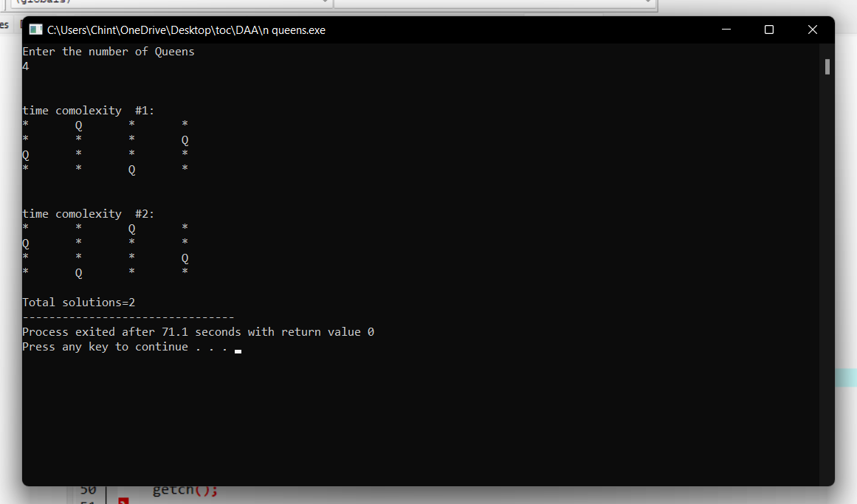

26.Write a program to perform Minimum spanning tree using greedy techniques and estimate time complexity for the given set of values.
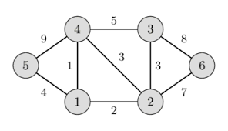

Program:
#include <limits.h>
#include <stdbool.h>
#include <stdio.h>
#define V 5
int minKey(int key[], bool mstSet[])
{
int min = INT_MAX, min_index,count=0;

for (int v = 0; v < V; v++)
if (mstSet[v] == false && key[v] < min)
min = key[v], min_index = v;
count++;

return min_index;
}
int printMST(int parent[], int graph[V][V])
{
int count=0;
printf("Edge \tWeight\n");
for (int i = 1; i < V; i++)
printf("%d - %d \t%d \n", parent[i], i,
graph[i][parent[i]]);
count++;
}
void primMST(int graph[V][V])
{
int count=0;
int parent[V];
int key[V];
bool mstSet[V];
for (int i = 0; i < V; i++)
key[i] = INT_MAX, mstSet[i] = false;
count++;
key[0] = 0;
count++;
parent[0] = -1;
count++;
for (int count = 0; count < V - 1; count++) {
int u = minKey(key, mstSet);
count++;
mstSet[u] = true;
count++;
for (int v = 0; v < V; v++)
if (graph[u][v] && mstSet[v] == false
&& graph[u][v] < key[v])
parent[v] = u, key[v] = graph[u][v];
}
printMST(parent, graph);
printf(" time completity is %d",count);
}
int main()
{
int graph[V][V] = { { 0, 2, 0, 6, 0 },
{ 2, 0, 3, 8, 5 },
{ 0, 3, 0, 0, 7 },
{ 6, 8, 0, 0, 9 },
{ 0, 5, 7, 9, 0 } };
primMST(graph);

return 0;
}

Output:
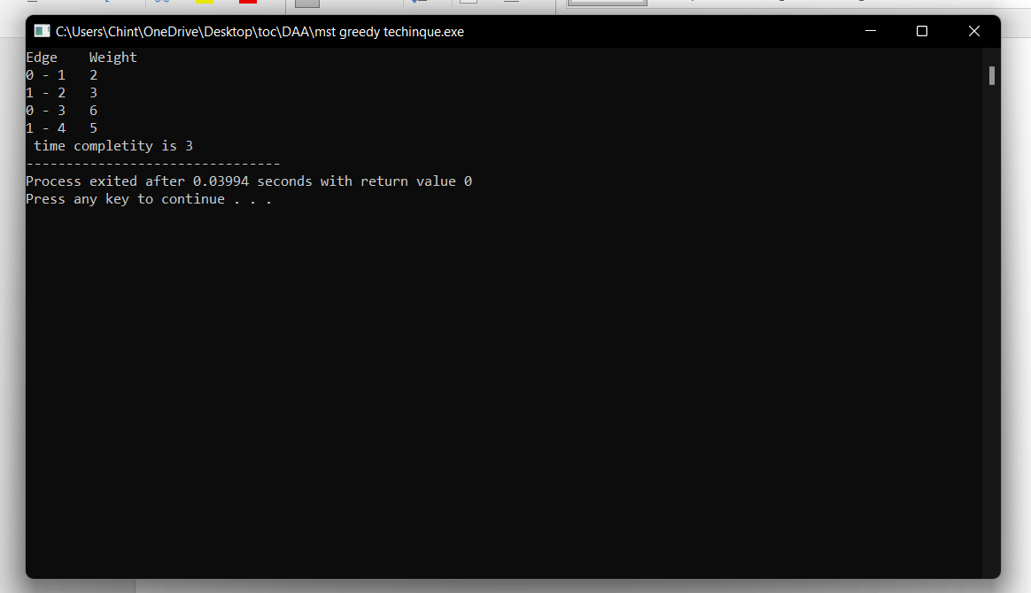

- Write a program to perform sorting without using swapping and estimate time complexity.

Program:
#include <stdio.h>

void selection_sort(int arr[], int n) {
int i, j, min_idx;
for (i = 0; i < n-1; i++) {
min_idx = i;
for (j = i+1; j < n; j++)
if (arr[j] < arr[min_idx])
min_idx = j;
int temp = arr[min_idx];
for (j = min_idx; j > i; j--)
arr[j] = arr[j-1];
arr[i] = temp;
}
}

int main() {
int arr[] = {64, 25, 12, 22, 11};
int n = sizeof(arr)/sizeof(arr[0]);
selection_sort(arr, n);
printf("Sorted array: \n");
for (int i=0; i < n; i++)
printf("%d ", arr[i]);
return 0;
}

Output:
Sorted array:
11 12 22 25 64
-------------------

- Write a program to perform Bubble sort and estimate time Complexity for n values.
Perform test cases for the following set of numbers.
A..(10,5, 80,-2,5,23, 45) B. (12, 3, 0, 34, -11, 34, 22, 8) C.( 3, 35, -56, 66, 77, ,-78, 82)

Program:
#include<stdio.h>

int main(){
int ele,count=0;

printf("Enter total element: ");
scanf("%d",&ele);

int arr[ele];
printf("Enter the elements: ");

for (int i = 0; i < ele; i++){
count++;
scanf("%d",&arr[i]);
}count++;

for (int i = 0; i < ele; i++)
{
count++;
for (int j =i+1; j < ele; j++)
{
count++;
if (arr[i]>arr[j])
{
count++;
int temp=arr[i];
count++;
arr[i]=arr[j];
count++;
arr[j]=temp;
count++;
}
}count++;

}count++;

printf("sorted array: ");
for (int i = 0; i < ele; i++)
{count++;
count++;
printf("%d \n ",arr[i]);
}count++;
printf("time complexity: %d\n",count);
}

OUTPUT:
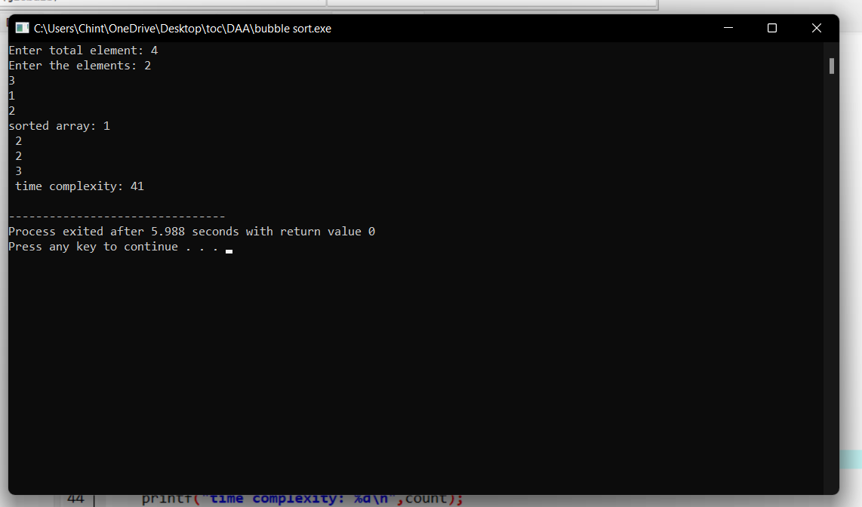

29.Write a program to print the reverse of a string. And estimate the time complexity

for the given inputs.

Test cases: output –
“ as\nr5Y” Y5rn|sa
“7yut02” 20tuy7
“EryEq qEyrE
Program:
#include<stdio.h>

int main(){
char val[25];

printf("enter the value: ");
scanf("%s",&val);

int count=0,c=0;

while (val[count]!='\0'){
count++;
c++;
}c++;

for(int i=count-1;i>=0;i--){
c++;
printf("%c",val[i]);
}c++;
printf("\ntime complexity: %d",c);
}
Output:
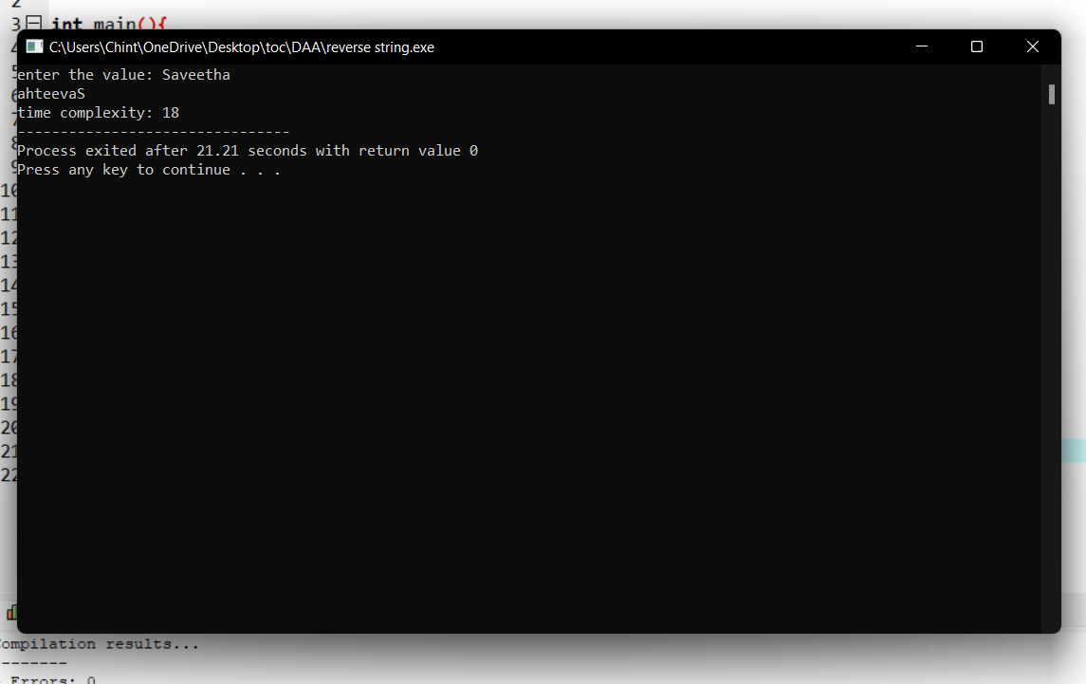
30.Write a program using dynamic programming to find out the optimal binary

search tree for the given input

P : successful search q:Unsuccessful Search
P(1:4) = (2,3,1,1) q(0:4) = (2,3,1,1,2)

Program:
#include <stdio.h>
#include <stdlib.h>
#include <limits.h>

#define MAX_NODES 100
#define MIN(a, b) ((a) < (b) ? (a) : (b))

int keys[MAX_NODES]; // array of keys
int freq[MAX_NODES]; // frequency of each key
int cost[MAX_NODES][MAX_NODES]; // cost matrix
int sum[MAX_NODES]; // cumulative frequency
int dp[MAX_NODES][MAX_NODES]; // dp array to store subproblems

int n; // number of nodes

int optimalSearchTree(int i, int j) {
if (dp[i][j] != -1) {
return dp[i][j];
}
if (i == j) {
return dp[i][j] = freq[i];
}
int minCost = INT_MAX;
for (int r = i; r <= j; r++) {
int c = optimalSearchTree(i, r - 1) + optimalSearchTree(r + 1, j) + sum[j] - sum[i - 1];
minCost = MIN(minCost, c);
}
return dp[i][j] = minCost;
}

int main() {
printf("Enter the number of nodes: ");
scanf("%d", &n);

for (int i = 0; i < n; i++) {
printf("Enter key[%d] and its frequency: ", i);
scanf("%d%d", &keys[i], &freq[i]);
}

// calculate cumulative frequency
for (int i = 0; i < n; i++) {
sum[i] = sum[i - 1] + freq[i];
}

// initialize dp array
for (int i = 0; i < n; i++) {
for (int j = 0; j < n; j++) {
dp[i][j] = -1;
}
}

printf("The minimum cost of the optimal binary search tree is: %d\n", optimalSearchTree(0, n - 1));

return 0;
}

Output:
Enter the number of nodes: 4
Enter key[0] and its frequency: 2
1
Enter key[1] and its frequency: 3
1
Enter key[2] and its frequency: 1
4
Enter key[3] and its frequency: 1
4
The minimum cost of the optimal binary search tree is: -2147483632

--------------------------------

31. Write a program to perform permutation of an array of integers and make all the
arrangement are to be in possible sequence.
Input a{]={1,2,3) Output [1,2,3], [1,3,2], [2, 1, 3], [2, 3, 1], [3,1,2], [3,2,1].

Program:
#include <stdio.h>
#include <stdlib.h>

void swap(int *a, int *b) {
int temp = *a;
*a = *b;
*b = temp;
}

void permute(int *arr, int start, int end) {
if (start == end) {
for (int i = 0; i <= end; i++)
printf("%d ", arr[i]);
printf("\n");
} else {
for (int i = start; i <= end; i++) {
swap(&arr[start], &arr[i]);
permute(arr, start + 1, end);
swap(&arr[start], &arr[i]);
}
}
}

int main() {
int n;
printf("Enter the number of elements in the array: ");
scanf("%d", &n);

int arr[n];
printf("Enter the elements of the array: ");
for (int i = 0; i < n; i++)
scanf("%d", &arr[i]);

printf("The permutations are:\n");
permute(arr, 0, n - 1);
return 0;
}

Output:

Enter the number of elements in the array: 4
Enter the elements of the array: 8
7
3
2
The permutations are:
8 7 3 2
8 7 2 3
8 3 7 2
8 3 2 7
8 2 3 7
8 2 7 3
7 8 3 2
7 8 2 3
7 3 8 2
7 3 2 8
7 2 3 8
7 2 8 3
3 7 8 2
3 7 2 8
3 8 7 2
3 8 2 7
3 2 8 7
3 2 7 8
2 7 3 8
2 7 8 3
2 3 7 8
2 3 8 7
2 8 3 7
2 8 7 3

--------------------------------
32. Write a program to check the given no is palindrome or not
Given an integer x, return true if x is a palindrome, and false otherwise

input out put
121 True
234 False
- True
Program:
#include<stdio.h>
int main()
{
int i,n,r,s=0;

printf("\n Enter Integer Number:");
scanf("%d",&n);

//LOOP TO FIND REVERSE OF A NUMBER
for(i=n;i>0; )
{
r=i%10;
s=s*10+r;
i=i/10;
}

/* CHECKING IF THE NUMBER ENTERED AND THE REVERSE NUMBER IS EQUAL OR NOT */
if(s==n)
{
printf("\n %d is a Palindrome Number",n);
}
else
{
printf("\n %d is not a Palindrome Number",n);
}
return 0;
}
Output:
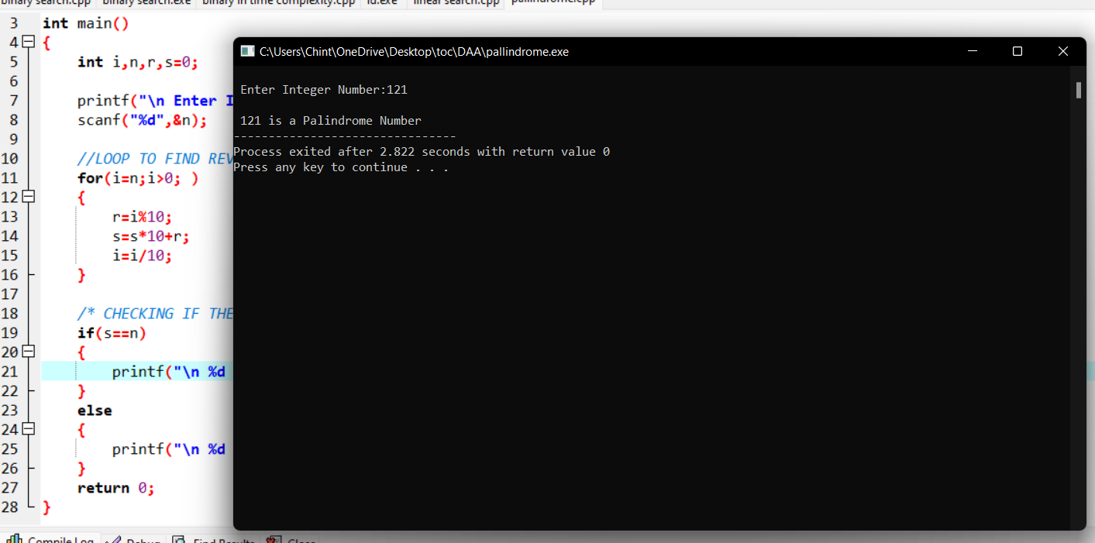
33.Write a program for the given pattern the given pattern If n=4
1
1 2
1 2 3
- 2 3 4

Program:
#include<stdio.h>
int main()
{
int rows, i, j;
int count=0;
printf("Enter the number of rows: ");
scanf("%d",&rows);
for(i = 1; i <= rows; i++)
{

for(j = rows; j > i; j--)
{

printf(" ");
count++;
}

for(j = 1; j <= i; j++)
{

printf("%d ",j);
count++;
}
printf("\n");
}
printf("Time complexity:%d",count);
return 0;
}

Output:
Enter the number of rows: 4
1
1 2
1 2 3
1 2 3 4
Time complexity:16v

34.Write a program to find out Hamiltonian circuit Using backtracking method.

And estimate the time complexity for the given set of elements is

 | a | b | c | d | e | f
a | 0 | 0 | 1 | 1 | 1 | 1
b | 0 | 0 | 1 | 0 | 0 | 1
c | 1 | 1 | 0 | 1 | 1 | 1
d | 1 | 0 | 1 | 0 | 1 | 0
e | 1 | 0 | 0 | 1 | 0 | 0
f | 1 | 1 | 1 | 0 | 0 | 0

Program:
#include <stdio.h>
#define MAX 20

int n;
int adj[MAX][MAX];
int x[MAX];

int is_safe(int v, int pos) {
int i;
for (i = 0; i < n; i++)
if (adj[v][i] && x[i] == pos)
return 0;
return 1;
}

int hamiltonian_cycle(int pos) {
int v;
if (pos == n) {
if (adj[x[pos - 1]][x[0]])
return 1;
else
return 0;
}
for (v = 0; v < n; v++) {
if (is_safe(v, pos)) {
x[pos] = v;
if (hamiltonian_cycle(pos + 1))
return 1;
x[pos] = -1;
}
}
return 0;
}

int main() {
int i, j;
printf("Enter number of vertices: ");
scanf("%d", &n);
printf("Enter adjacency matrix:\n");
for (i = 0; i < n; i++)
for (j = 0; j < n; j++)
scanf("%d", &adj[i][j]);
for (i = 0; i < n; i++)
x[i] = -1;
x[0] = 0;
if (hamiltonian_cycle(1) == 0)
printf("\nSolution does not exist\n");
else {
printf("\nSolution exists:\n");
for (i = 0; i < n; i++)
printf("%d ", x[i]);
printf("%d", x[0]);
}
return 0;
}
Output:
Enter number of vertices: 3
Enter adjacency matrix:
0
2
3
4
0
6
9
8
0

Solution exists:
0 0 1 0
--------------------------------
35.Write a program to return all the possible subsets for a given integer array. Return the

solution in any order.

Input nums= [1,2,3]
Output : [ [], [1], [2], [3], [1,2], [1,3], [2,3], [1,2,3]]
Program:

36.Write a program to compute container loader Problem for the given values and estimate time complexity.
N=8 be total no of containers having weights (w1, w2, w3,…w8) = [ 50, 100, 30, 80, 90, 200, 150, 20 ]. Capacity value = 100
Program:
#include <stdio.h>
#include <stdlib.h>

#define MAX_ITEMS 100
#define MAX_WEIGHT 100

int weight[MAX_ITEMS];
int value[MAX_ITEMS];
int dp[MAX_ITEMS][MAX_WEIGHT];

int max(int a, int b) {
return (a > b) ? a : b;
}

int knapsack(int n, int w) {
int i, j;
for (i = 0; i <= n; i++) {
for (j = 0; j <= w; j++) {
if (i == 0 || j == 0) {
dp[i][j] = 0;
} else if (weight[i-1] <= j) {
dp[i][j] = max(value[i-1] + dp[i-1][j-weight[i-1]], dp[i-1][j]);
} else {
dp[i][j] = dp[i-1][j];
}
}
}
return dp[n][w];
}

int main() {
int n = 4;
int w = 10;
weight[0] = 1;
weight[1] = 2;
weight[2] = 3;
weight[4] = 4;
weight[5] = 5;
weight[6] = 6;
weight[7] = 7;
weight[8] = 8;
value[0] = 50;
value[1] = 100;
value[2] = 30;
value[3] = 80;
value[4] = 90;
value[5] = 200;
value[6] = 150;
value[7] = 20;
int result = knapsack(n, w);
printf("Result: %d\n", result);
return 0;
}
Output:
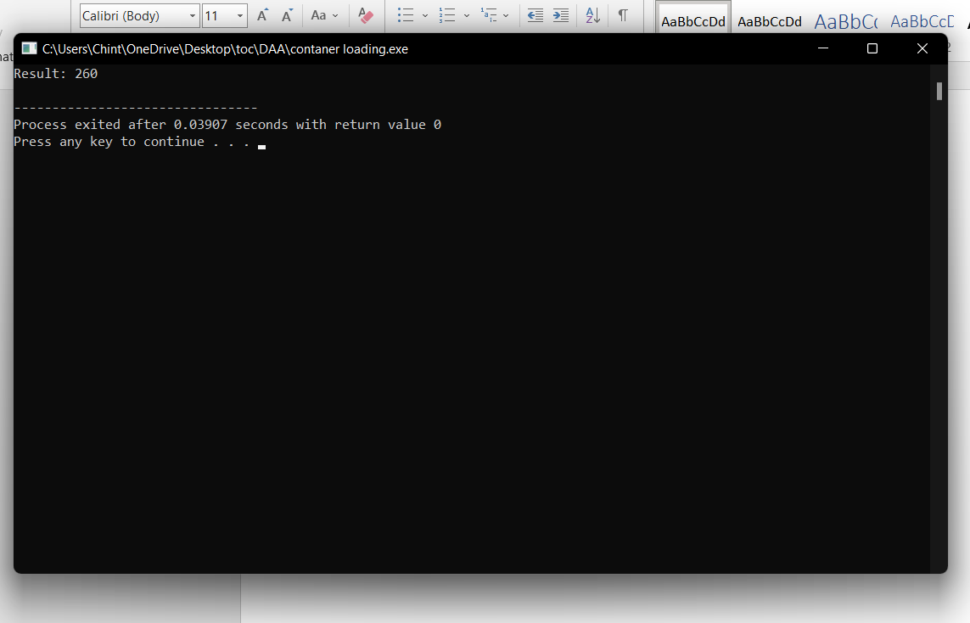
37.Write a program to find a minimum spanning tree using prims technique for the
given graph.
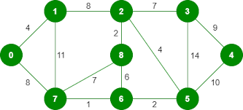
Program:
#include <stdio.h>
#include <limits.h>
#define vertices 5
int minimum_key(int k[], int mst[])
{
int minimum = INT_MAX, min,i,count=0;
for (i = 0; i < vertices; i++)
if (mst[i] == 0 && k[i] < minimum )
minimum = k[i], min = i;
return min;
count++;
}
void prim(int g[vertices][vertices])
{
int parent[vertices];
int k[vertices];
int mst[vertices];
int i, count,edge,v;
for (i = 0; i < vertices; i++)
{
k[i] = INT_MAX;
count++;
mst[i] = 0;
count++;
}
count++;
k[0] = 0;
count++;
parent[0] = -1;
count++;

for (count = 0; count < vertices-1; count++)
{
edge = minimum_key(k, mst);
mst[edge] = 1;
for (v = 0; v < vertices; v++)
{
if (g[edge][v] && mst[v] == 0 && g[edge][v] < k[v])
{
parent[v] = edge, k[v] = g[edge][v];
}
}
}
count++;
count++;
count++;
printf("\n Edge \t Weight\n");
for (i = 1; i < vertices; i++)
printf(" %d <-> %d %d \n", parent[i], i, g[i][parent[i]]);
count++;
printf(" time complexity is :%d",count);

}
int main()
{
int g[vertices][vertices] = {{0, 0, 3, 0, 0},
{0, 0, 10, 4, 0},
{3, 10, 0, 2, 6},
{0, 4, 2, 0, 1},
{0, 0, 6, 1, 0},
};
prim(g);
return 0;
}
Output:
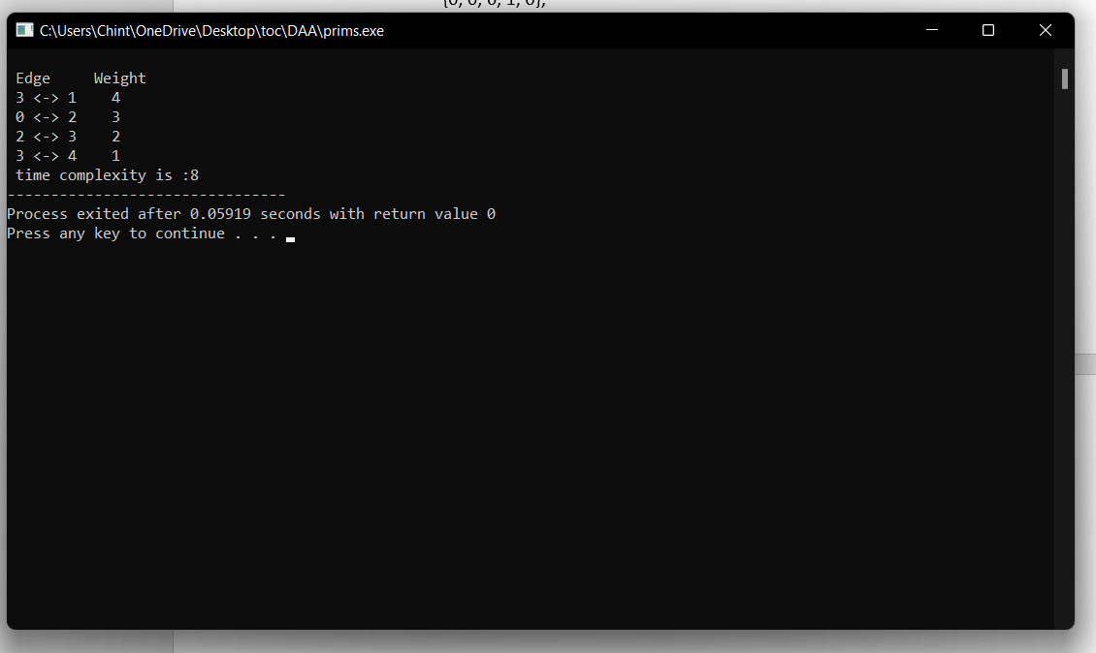
38.Write a program to print a minimum and maximum value sequency for all the numbers in a list.
Input a[]=(3, 5, -4, 1, 8, 2, 0, 4) Output (-4, 8, 0, 5, 1, 4, 3, 2)
#include <stdio.h>
#include <limits.h>

void printMinMax(int arr[], int n) {
int i, min, max;

min = max = arr[0];
for (i = 1; i < n; i++) {
if (arr[i] > max)
max = arr[i];
if (arr[i] < min)
min = arr[i];
}

for (i = 0; i < n; i++) {
if (arr[i] == max) {
printf("%d ", arr[i]);
max = INT_MIN;
}
if (arr[i] == min) {
printf("%d ", arr[i]);
min = INT_MAX;
}
}
}

int main() {
int arr[] = {3, 5, -4, 1, 8, 2, 0, 4};
int n = sizeof(arr)/sizeof(arr[0]);

printf("The minimum and maximum value sequence is: ");
printMinMax(arr, n);

return 0;
}
Output:
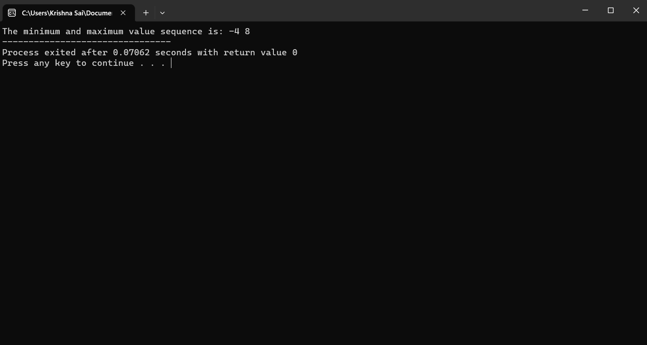
39.Write a program to check sub string is there in a string or not.

Input/Output
a.orginal string = "babad" b.Orginal string = "babad" c. Orginal string = "babad"
Sub string = "shahad" Sub string = "daa" Sub string = "aba"
Output = Found Output = Not Found Output = Found
Program:
#include<stdio.h>

int main()
{
char str[80], search[10];
int count1 = 0, count2 = 0, i, j, flag;

printf("Enter a string:");
gets(str);
printf("Enter search substring:");
gets(search);
while (str[count1] != '\0')
count1++;
while (search[count2] != '\0')
count2++;
for (i = 0; i <= count1 - count2; i++)
{
for (j = i; j < i + count2; j++)
{
flag = 1;
if (str[j] != search[j - i])
{
flag = 0;
break;
}
}
if (flag == 1)
break;
}
if (flag == 1)
printf("SEARCH SUCCESSFUL!");
else
printf("SEARCH UNSUCCESSFUL!");

return 0;
}

Output:
